ANALYZING THE USER BEHAVIOR TO IMPROVE E-COMMERCE BUSINESS

Amrutha Bhagwat¹, Pritesh K Jain²,Reena D K³

Department of Information Science And Engineering
Shree Dharmasthala Manjunatheshwara College of Engineering and Technology,
Dharwad- 580 002
¹amruthak790@gmail.com 9739592390
²2sd08is036@gmail.com 8553949106
³rdk327@gmail.com 9164533374

Stream Code=CPT

ANALYZING THE USER BEHAVIOR TO IMPROVE
E-COMMERCE BUSINESS
-AN WEB USAGE BASED APPROACH

Amrutha Bhagwat¹,Pritesh K Jain² ,Reena D K³

Department of Information Science And Engineering
Shree Dharmasthala Manjunatheshwara College of Engineering and Technology,
Dharwad- 580 002
¹amruthak790@gmail.com 9739592390
²2sd08is036@gmail.com 8553949106
³rdk327@gmail.com 9164533374

Abstract- E-business management is an on-going process of understanding consumer needs and developing online solutions to meet those needs. This paper mainly focuses on user identification and knowing his behavior by maintaining each user profile in database and apply this to improve e-commerce business. It uses the methods that introduces the concept of Web usage mining and describes the process of Web usage mining in detail. The paper mainly takes log file gerated from tomcat server and apply the preprocessing using efficient algorithms, further pattern discovery is applied. This paper helps in understanding customers and achieving website structure optimization for improvement of E-business. We introduce a web mining solution to e-commerce to discover hidden patterns and business strategies from web data. Finally it establishes the relationship between Web mining and e-commerce and how to use Web usage mining technology in e-commerce and give efficient tool that can be used by the owners of E-commerce business.

- INTRODUCTION

Web Usage Mining is a part of Web Mining, which, in turn, is a part of Data Mining. As Data Mining involves the concept of extraction meaningful and valuable information from large volume of data, Web Usage mining involves mining the usage characteristics of the users of Web Applications. This extracted information can then be used in a variety of ways such as, improvement of the application, checking of fraudulent elements etc. Web Usage Mining is often regarded as a part of the Business Intelligence in an organization rather than the technical aspect. It is used for deciding business strategies through the efficient use of Web Applications. Web mining technique is used to identify the user surfing on the net and also analyze each user’s behavior. The analyzed information is helpful to improve the website and in turn E-Commerce business.

- Introduction of Technology
Web Usage Mining is often regarded as a part of the Business Intelligence in an organization rather than the technical aspect. It is used for deciding business strategies through the efficient use of Web Applications. It is also crucial for the Customer Relationship Management (CRM) as it can ensure customer satisfaction as far as the interaction between the customer and the organization is concerned. The major problem with Web Mining in general and Web Usage Mining in particular is the nature of the data they deal with. With the upsurge of Internet in this millennium, the Web
Data has become huge in nature and a lot of transactions and usages are taking place by the seconds. Apart from the volume of the data, the data is not completely structured. It is in a semi-structured format so that it needs a lot of preprocessing and parsing before the actual extraction of the required information. In this project, we have taken up a small part of the Web Usage Mining process, which involves the Preprocessing, User Identification, Bot-removal and Analysis of the tomcat Server Logs.

- Objective of the Presentation
The objective of the presentation is as follows:
- Maintaining the user profile for each user identification.
- To understand the customer’s behaviour based on their navigation in the websites.
- To give a good interfacing web site to the customer for online shopping.
- Improvement of E-Commerce business.

- Motivation
In the current era, we are witnessing a surge of Web Usage around the globe. A large volume of data is constantly being accessed and shared among a varied type of users; both humans and intelligent machines. Thus, taking up a structured approach to control this information exchange, has what made Web Mining one of the hot topics in the field of Information Technology. This very reason motivated us to come up with this idea.

- ANALYSIS OF THE LOG FILE
First Part of Analysis was preprocessing. Preprocessing segregated all the details provided in the log file into a structured form. Language used: JAVA Data Structures used: Linear Arrays: ip[], time[], content[], httpmethod[], httpstatus[],bandwidth[] etc. The preprocessing program collected the details in the appropriate data structures and also identified whether an entry is a bot entry or a valid user entry.
TABLE 1. SAMPLE WEB LOG DATA
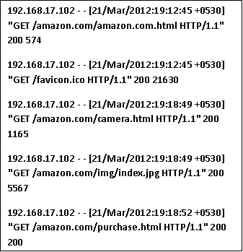

- PRODUCT PERSPECTIVE
In the figure shown above the data is collected from the server in the internet. The data which is collected is in the form of file known as server web log file. The information in the server web log file is taken through several phases.
A) Data Collection.
B) Data pre processing.
C) Pattern discovery.
D) Pattern analysis.

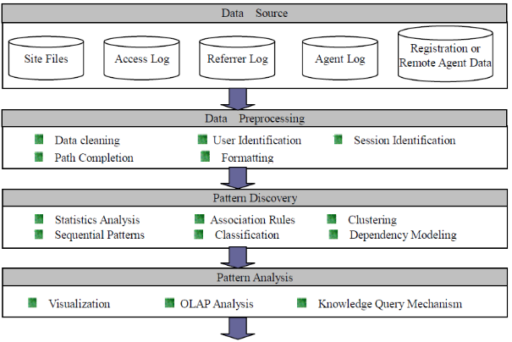
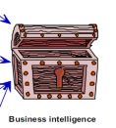
Website Improvement

Business Intelligence

Fig 1. OVERVIEW OF BUSINESS INTELLIGENCE
After the data pre processing phase we apply user identification algorithm for identifying the user’s surfing on web and understanding their behavior. This analyzed data is presented to the website owner using our software for his website and therefore this helps his e-commerce business improvement.

- Data Collection
Users visit e-commerce website through hyperlink, which can be represented by click flow abstractly and recorded in the server log. From further researches on the behavior data of each customer collected, valuable information and knowledge can be obtained. The proposed work focuses to collect and analyze users' browsing behaviors and observe users' frequent access through data-mining. The data source in this system mainly refers to Web log files.
In Web Usage Mining, data can be collected in server logs, browser logs, proxy logs, or obtained from an organization's database. These data collections differ in terms of the location of the data source, the kinds of data available, the segment of population from which the data was collected, and methods of implementation. The data sources used in Web Usage Mining may include web data repositories like:
- Web Server Logs – These are logs which maintain a history of page requests. The W3C maintains a standard format for web server log files, but other proprietary formats exist. More recent entries are typically appended to the end of the file. Information about the request, including client IP address, request date/time, page requested, HTTP code, bytes served, user agent, and referrer are typically added. These data can be combined into a single file, or separated into distinct logs, such as an access log, error log, or referrer log. However, server logs typically do not collect user-specific information. These files are usually not accessible to general Internet users, only to the webmaster or other administrative person. A statistical analysis of the server log may be used to examine traffic patterns by time of day, day of week, referrer, or user agent. Efficient web site administration, adequate hosting resources and the fine tuning of sales efforts can be aided by analysis of the web server logs. Marketing departments of any organization that owns a website should be trained to understand these powerful tools.
- Proxy Server Logs - A Web proxy is a caching mechanism which lies between client browsers and Web servers. It helps to reduce the load time of Web pages as well as the network traffic load at the server and client side. Proxy server logs contain the HTTP requests from multiple clients to multiple Web servers. This may serve as a data source to discover the usage pattern of a group of anonymous users, sharing a common proxy server.
- Browser Logs – Various browsers like Mozilla, Internet Explorer etc. can be modified or various JavaScript and Java applets can be used to collect client side data. This implementation of client-side data collection requires user cooperation, either in enabling the functionality of the JavaScript and Java applets, or to voluntarily use the modified browser. Client-side collection scores over server-side collection because it reduces both the bot and session identification problems.

- Data Preprocessing
Log File is the input to pre-processing block. A Web log is a file to which the Web server writes information each time a user requests a resource from that particular site. Data preprocessing a web usage mining model (Web-Log preprocessing) aims to reformat the original web logs to identify user’s access sessions. In this paper we use Tomcat server for generation of log file and show the efficiency of the algorithms. The Web server usually registers all users’ access activities of the website as Web server logs. So the main steps of this phase are:
- Extract the web logs that collect the data in the web server.
- Clean the web logs and remove the redundant information.
- Parse the data and put it in a relational database or a data warehouse and data is reduced to be used in frequency analysis to create summary reports.

Field Extraction:
The log entry contains various fields which need to be separate out for the processing. The process of separating field from the single line of the log file is known as field extraction. The server used different characters which work as separators. The most used separator character is ',' or 'space ' character. The FieldExtract algorithm is given below.

Input: Log File
Output: DB
Begin
1. Open a DB connection
2. Create a table to store log data
3. Open Log File
4. Read all fields contain in Log File
5. Separate out the Attribute in the string Log
6. Extract all fields and Add into the Log Table (LT)
7. Close a DB connection and Log File
End
Algorithm for field extraction

Data Cleaning:
Data cleaning eliminates irrelevant or unnecessary items in the analyzed data. A web site can be accessed by millions of users. The records with failed HTTP status codes also may involve in log data. Data cleaning is usually sitespecific, and involves extraneous references to embedded objects that may not be important for purpose of analysis, including references to style files, graphics or sound files. Therefore some of entries are useless for analysis process that is cleaned from the log files. By Data cleaning, errors and inconsistencies will be detected and removed to improve the quality of data [8].An algorithm for cleaning the entries of server logs is presented below –

Input: Log Table (LT)
Output: Summarized Log Table (SLT)
‘*’ = access pages consist of embedded objects
(i.e .jpg, .gif, etc)
‘**’ =successful status codes and requested methods (i.e
200, GET etc)
Begin
1. Read records in LT
2. For each record in LT
3. Read fields (Status code, method)
4. If Status code=‘**’and method= ‘**’ and record not equal to previous record.
Then
5. Get IP_address and URL_link
6. If suffix.URL_Link= {*.gif,*.jpg,*.css}
Then
7. Remove suffix.URL_link
8.Save IP_sddress, time, URL_Link, method and status code.
End if
Else
10. Next record
End if
End
Algorithm for data cleaning
Our log file of date 29/03/2012 has 39 records and after preprocessing with this algorithms we directly get only 15 records and which are required for further ptrcessing.
- User Identification
For analyzing user access behaviors, unique users must be identified. As mentioned earlier, users are treated as anonymous in most web servers. We can simplify user identification to client IP identification. In other words, requests from the same IP address can be regarded as from the same user and put into the same group under that user. In order to identify users more accurately, some other information from the web logs may be helpful. The agent filed in web logs records information on the client browser and operating system. Since different users may access the website through the same proxy server, the IP address may be the same. However, the agent type may not be the same in many cases, it is quite reasonable to assume that each different agent type for the same IP address represents a different user.

- Session Identification
For logs from a user that spans a long period of time, it is very likely that the user has visited the website more than once. The goal of session identification is to divide web logs of each user into individual access sessions. The simplest method is to set a timeout threshold. If the difference between the request time of two adjacent records from a user is greater than the timeout threshold, it can be considered that a new access session has started. In this research, we use 30 minutes as the default timeout threshold.

- Pattern Discovery
Pattern Discovery “draws upon methods and algorithms developed from several fields such as data mining, machine learning and pattern recognition”. Several methods and techniques had been developed for this step that can be summarized as follows:
- Clustering of users help to discover groups of users with similar navigation patterns (provide personalized Web content).
- Association Rules discover correlations among pages accessed together by a client.
- Sequential Patterns extract frequently occurring inter-session patterns such that the presence of a set of items is followed by another item in time order.
We are mainly applying association rule which is detailed here:
For web usage mining, association rules can be used to find correlations between web pages (or products in an e-commerce website) accessed together during a server session. Such rules indicate the possible relationship between pages that are often viewed together even if they are not directly connected, and can reveal associations between groups of users with specific interests. Apart from being exploited for business applications, the associations can also be used for web recommendation, personalization or improving the system’s performance through predicting and pre-fetching of web data.
Discovery of such rules for organizations engaged in electronic commerce can help in the development of effective marketing strategies. But, in addition, association rules discovered from WWW access logs can give an indication of how to best organize the organization's Web space.
For example, if one discovers that 80% of the clients accessing /computer/products/printer.html and /computer/products /scanner. html also accessed, but only 30% of those who accessed /computer/products also accessed computer/products/scanner.html, then it is likely that some information in printer.html leads clients to access scanner.html.
This correlation might suggest that this information should be moved to a higher level to increase access to scanner.html. This also helps in making business strategy that people who want to buy printer; they are also interested in buying scanner. So vendors can offer some discount on buying combo pack of printer and scanner. Or they can offer discount on one item for the purchase of both or they can apply buy one, get one free strategy.
Since usually such transaction databases contain extremely large amounts of data, current association rule discovery techniques try to prune the search space according to support for items under consideration. Support is a measure based on the number of occurrences of user transactions within transaction logs. Discovery of such rules for organizations engaged in electronic commerce can help in the development of effective marketing strategies.

- Pattern Analysis
Pattern Analysis is the third phase of Web Usage Mining. The task of this stage is to remove irrelevant rules or patterns and extract the interesting rules or patterns from results of pattern discovery. In this paper we fetch the following details in this final step of WUM:
- Unique identification of the user.
- User Behavior.
- Frequently visited Web Pages.
- Items sold to the maximum number.

- RESULTS

Input:
- Website name.

Outputs:
- Decreasing order of purchased items.
- Decreasing order of time spent on web pages with no purchase.
- Three interested web pages with maximum visited users.
- Number of unique users visited the website and number of users puschased the items.

Table 2:amazon.com website to browse and create website
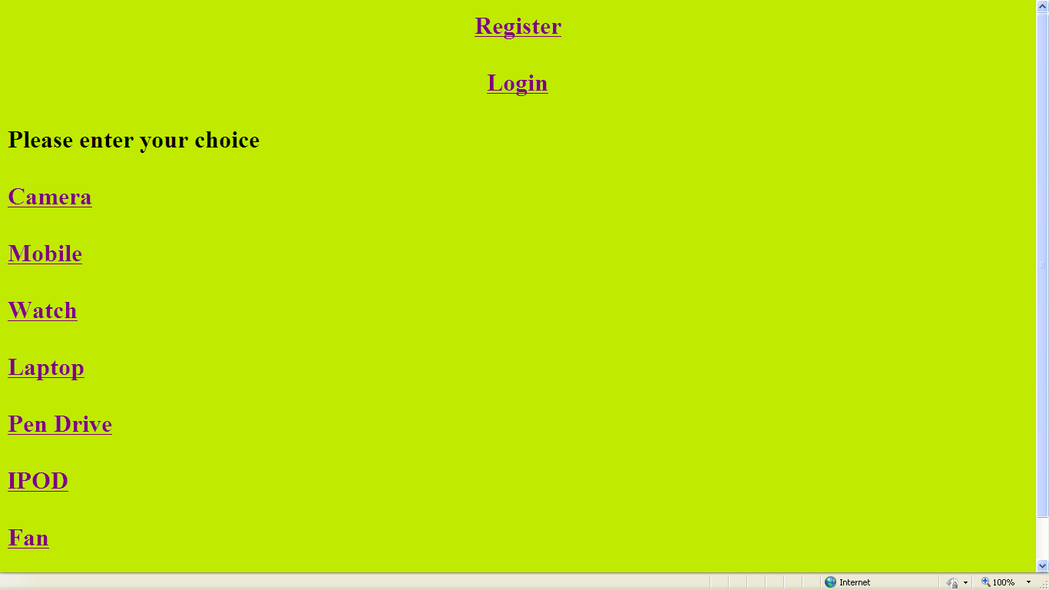
Table 3.Sapshot of Result in Browser for amazon.com as input website name
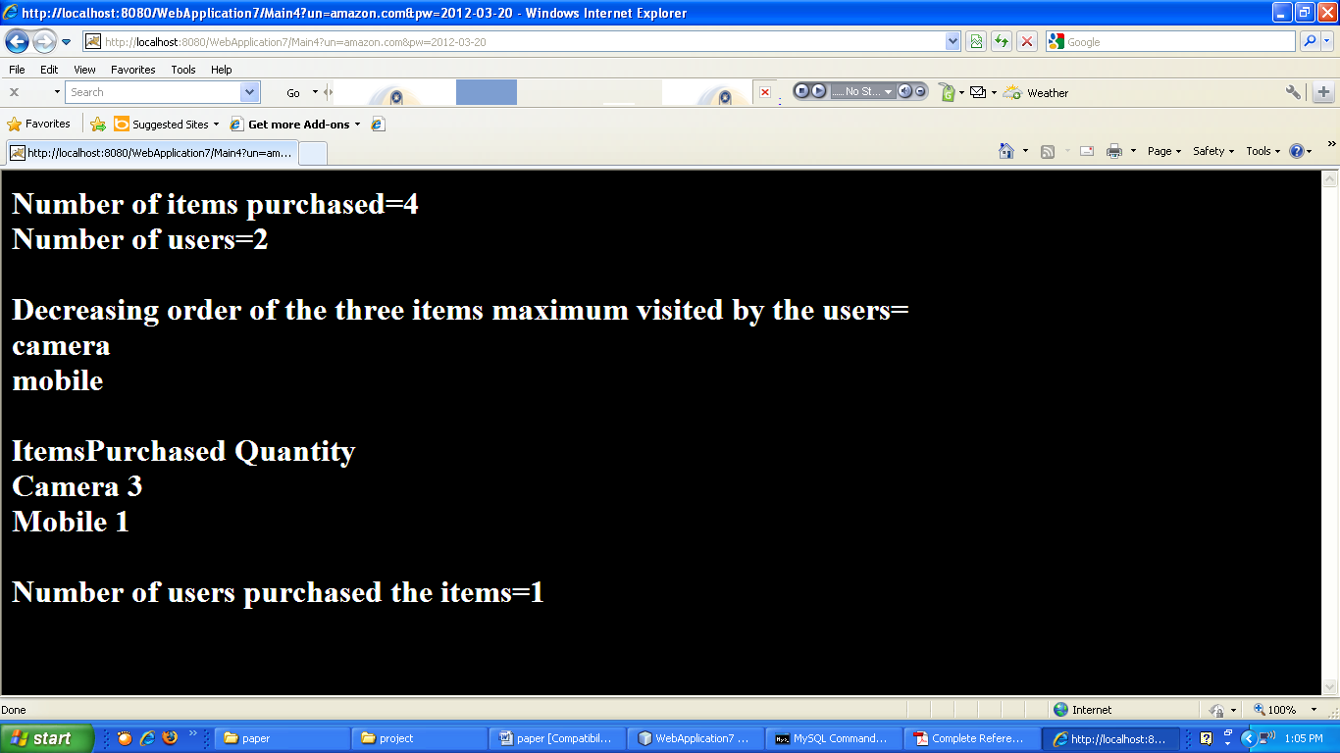

- APPLICATION AREAS

- Shortening Paths of High visit Pages: The pages which are frequently accessed by the users can be seen as to follow a particular path. These pages can be included in an easily accessible part of the Website thus resulting in the decrease in the navigation path length.
- Eliminating or Combining Low Visit Pages: The pages which are not frequently accessed by users can be either removed or their content can be merged with pages with frequent access.
- Redesigning Pages to help User Navigation: To help the user to navigate through the website in the best possible manner, the information obtained can be used to redesign the structure of the Website.
- Redesigning Pages For Search Engine Optimization: The content as well as other information in the website can be improved from analyzing user patterns and this information can be used to redesign pages for Search Engine Optimization so that the search engines index the website at a proper rank.
- Help Evaluating Effectiveness of Advertising Campaigns: Important and business critical advertisements can be put up on pages that are frequently accessed.

- CONCLUSION
Acquiring knowledge about user preferences in a web site can be the key for continuous improvement of the site. A way to obtain it consists in understanding the user's browsing behavior, analyzing the web log files with data mining techniques. When a visitor enters a Web site, the selected pages have direct relation with the desired information he/she is looking for. The ideal structure of a web site should support the visitors in finding such information. However, reality is quite different. In many cases, the structure of a Web site does not help to find the desired information, although a page that contains it, does exist. Studying visitors behavior is important in order to create more attractive contents, to predict her/his preferences, and to prepare links with suggestions, among others. These research initiatives aim at facilitating web site navigation, and in the case of commercial sites, at increasing market shares, transforming visitors into customers, increasing customers loyalty and predicting their preferences. The paper concludes the relationship between Web mining and e-commerce and how to use Web mining technology in improvement of e-commerce business by giving sufficient knowledge through user profile.

ACKNOWLEDGMENT
The authors thank Prof. V K Parvati, Head of the department of Information Science and Engineering for providing sufficient knowledge to do project on this research topic. The authors thank Prof. Leena Sakari for her constant
support and guidance.

REFERENCES
- R. Cooley, B. Mobasher, and J. Srivastava, “Data preparation for mining World Wide Web browsing patterns,” Knowledge and Information Systems
- IEEE papers on “web usage mining” and “e- commerce business improvement”.
- Jaideep Srivastava , Robert Cooley, Mukund Deshpande, Pang-Ning Tan, and Web Usage Mining: Discovery and Applications of Usage Patterns from Web Data.
- G. Castellano, A. M. Fanelli, M. A. Torsello. “Log Data Preparation for Mining Web Usage Patterns”. IADIS International Conference Applied Computing 2007, pg 371-378.
- José Roberto de Freitas Boullosa. "An Architecture for Web Usage Mining".
- Yan Wang.” Web Mining and Knowledge Discovery of Usage Patterns”. CS 748T Project. February, 2000.
- Martinez E. Karamcheti V. “A Prediction Model for User Access Sequence" .In WEBKDD Workshop: Web Mining for usage Patterns and user Profile, July 2002.

